Burðardyggur fiskiskapur eftir upsa
Luis Ridao Cruz
luisr@hav.fo
Havstovan

- Introduction
- Methods
- Results
- References

Introduction
Until 2009 ICES has based its advice on the so-called precautionary approach (PA) which was developed a decade ago following the adoption of the United Nations Fish Stocks Agreement (UNFSA 1995). In response to the global commitment agreed at the World Summit on Sustainable Development in 2002 the European Commission (EC) adopted a policy to rebuild fisheries to MSY (Maximum Sustainable Yield) which aims at adjust fishing mortality (F) to the level corresponding to MSY (F_{msy}) by 2015.
In absence of management plans the advice provided by the precautionary approach framework called for a swift restoration of biomass (one year if possible) that often translated into draconian management measures if followed to the letter. There is also an issue associated with susceptible changes in advice inherently attached to the uncertainty in recruitment and stock size in the proximities of biomass reference points.
ICES encourages the development of management plans that conform to the precautionary principle but it has proven difficult to evaluate their performance and in some cases the relevant management authorities have not agreed therein.
Due to the limitations discussed above ICES convened a workshop on the framework for advice including participants from the science and management community. At the 2009 ICES Advisory Committee meeting the results of the workshop were presented and it was agreed to substitute the PA framework with the new MSY framework for management advice. The MSY concept conforms however with the PA approach but instead of focusing on avoiding impaired recruitment the advice will aim at a desired outcome, i.e., a high sustainable long term yield (MSY). The new framework uses both fishing mortality and biomass reference points (F_{msy} and MSYB_{trigger}). F_{msy} is the fishing mortality that in the long-term – everything else being equal – will maximize long term average yield. MSYB_{trigger} is a biomass reference point that triggers a cautious response to maintain a stock within a desirable stock size range, i.e., fluctuating around a notional value of B_{MSY} and therefore works as a harvest control rule (HCR). MSYB_{trigger} is a biomass point which is expected with a low probability in a fully productive stock which is fished at F_{msy}.
The ICES MSY framework is depicted in Figure 1.1.
Figure 1.1. ICES MSY framework. SSB is the estimated SSB in the beginning of the year to which the advice applies (advice year) (e.g. for the assessment performed in 2011 with data until 2010, the reference SSB will be the projected SSB at the beginning of 2012). F_{advice} is the fishing mortality that is the basis for the advice.
SSB (beginning of advice year)
F_{Advice}
BMSY_{trigger}
F
F_{MSY}

Faroe saithe is assessed through ICES at the North Western Working Group (NWWG). During discussions in the group it was noted that identifying a single F_{MSY} value is almost an impossible task and thus only feasible to identify a range of fishing mortalities that would conform to the MSY concept. As an example Figure 1.2 shows the results of traditional yield-per-recruit calculations with and without a stock-recruitment relation (SR) using the selection pattern observed since 1996. The suggested approach to find candidates for F_{msy} is the use of management strategies evaluation (MSE) in a stochastic framework, i.e., taking into account sources of uncertainty.
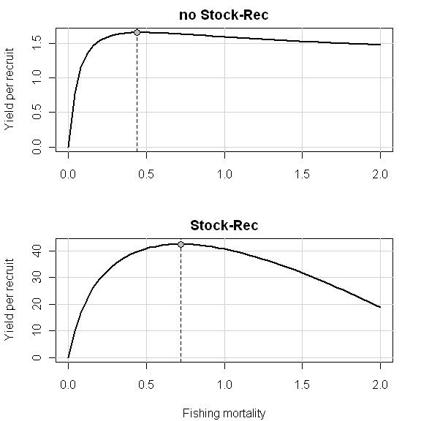
Figure 1.2. Faroe saithe. Expected maximum yield-per-recruit in absence of a stock-recruitment (SR) relation (upper figure) and using Ricker SR (Rec ~ a*SSB*exp(-b*SSB))(lower figure). F_{msy}=0.44 (upper figure) and F_{msy}=0.72 (lower figure)

Methods
In order to estimate F_{msy} for faroe saithe a Management Strategy Evaluation (MSE) is performed using a harvest control rule (HCR) in the FLR environment (Fisheries Library in R, http://wiki.flr-project.org/)
The MSE approach requires mathematical representations of two systems: a ‘true’ system and an ‘observed’ one. The ‘true’ system is represented by the operating model (OM) that simulates the real world. In contrast, the ‘observed’ system represents the conventional management procedure (MP), from the data collection through stock assessment to the management implementation. The present MSE evaluation uses the input data from the North Western Working Group stock assessment as the basis for the Operating Model and makes assumptions about the selection pattern of the fishing fleet and its dynamics.
The model comprises a single stock (faroe saithe) that is fished by a single fleet. It implements a harvest control rule through a management procedure that explicitly models the stock assessment process and time lag (2 years) in implementing the management advice (delay between the gathering of data and making a management decision, i.e. setting the current fishing effort) which explicitly addresses uncertainty in recent parameter estimates.
The stock recruitment relation used is the Hockey-stick or segmented regression with the breaking point estimated in addition to random noise on top of it reflecting the high variability in historical recruitment estimates (CV=0.5).

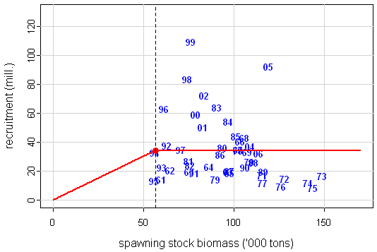
Figure 2.1. Faroe saithe. Relation between spawning stock biomass (SBB) and numbers of 3-year old saithe entering the stock. Numbers represent the yearclass and the red line the optimal fit of Hockey-stick function with the estimated breaking point SSBcut=55 kt (red point)

Fishing mortality (F) is estimated as the product of fishing effort, catchability (q=1) and selection pattern(sel) (Eq. 2.1.)

$F=effort*q*sel$ (Eq 2.1)
The observed selection pattern since 1996 is used in the simulations which correspond to the introduction of the fishing days quota in the Faroese management system (Figure 2.2.)

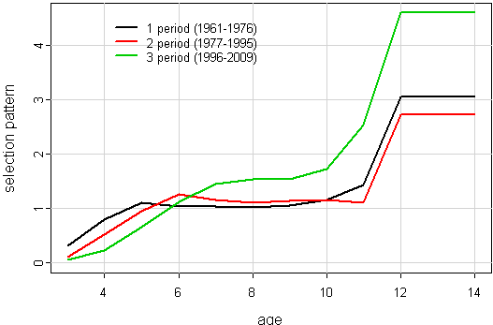
Figure 2.2. Faroe saithe. Selection pattern for three different periods since 1961. Selectivity corresponding to the introduction of the fishing days system (1996-2009 ) in the simulations (green line)
Maturity-at-age is fixed while stochasticity is included in weights-at-age with a CV=0.18 (coefficient of variation) applied to all age groups to somehow replicate the observed fluctuations pattern (Figure 2.3.)

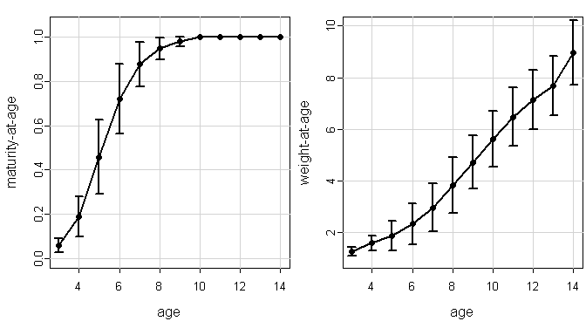
Figure 2.3. Faroe saithe. Maturity- and weight-at-age used in the simulations (vertical lines represent variability associated with the estimates)
The data sampling of catches and tuning fleets is carried out by multiplying by random noise, i.e., age-disaggregated catches and survey indices are not exact fluctuating around some mean value (Figure 2.4.)

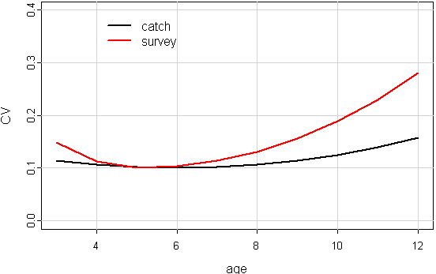
Figure 2.4. Faroe saithe. Variability in age-disaggregated commercial catches and tunning indices.

Natural mortality was fixed to M=0.2.
Simulations were performed 1000 times on a 40-year forward period with the historical period being replicated in the OM.

Results
Unlike the flat curves obtained from traditional yield-per-recruit calculations (Figure 1.2) curves from simulations show a relatively well defined maximum at F_{msy} =0.28 (broken lines represent the 5th and 95th percentile of the yield-per-recruit while and red line is the corresponding spawning-stock-biomass per-recruit)(Figure 3.1) The reason for this difference is that when fishing mortality is above certain level (>0.3) some of the stochastic runs will lead to spawning stock being below the break point in the stock-recruitment function so recruitment and subsequent landing s will be reduced. The knife-edge drop in yield is caused by the Hockey-stick ssb-rec used in the simulations. The breakpoint of 55 kt. in the segmented regression or the revised B_{pa}=60 000 t. (see Section 2. Demersal stocks in the Faroe Area, Subsection 2.1.7 Faroe saithe, NWWG Report 2011) could be candidates for B_{trigger} the point at which fishing mortality should be reduced according to the MSY framework. Results of the simulations are shown in Figure 3.2 (solid black line represents mean, yellow lines 25% and 75% percentiles and red lines show the 5% and 95% percentiles of stock parameters)
For faroe saithe the point estimate F_{msy} =0.28 is used by ICES as the basis for advice in 2011 but at the same time it is regarded as provisional. An alternative approach for stock management is the setting of a Harvest control Rule (HCR) or management plans which conform to the MSY frame work and is agreed upon by scientists, managers and stakeholders, an initiative encouraged by ICES as an alternative to fixed F-based exploitation strategies.
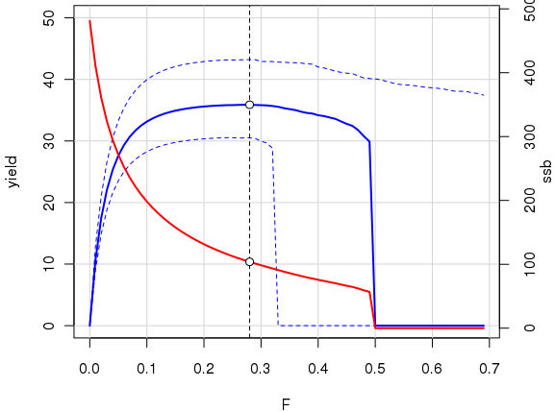
Figure 3.1. Faroe saithe. Yield-per-recruit (tonnes)(solid blue line) and spawning stock biomass-per-recruit (‘000 tonnes)(solid red line) from stochastic simulations. F_{msy}=0.28 ans SSB_{msy}=101 kt. Broken blue lines show the 5% and 95% percentiles.
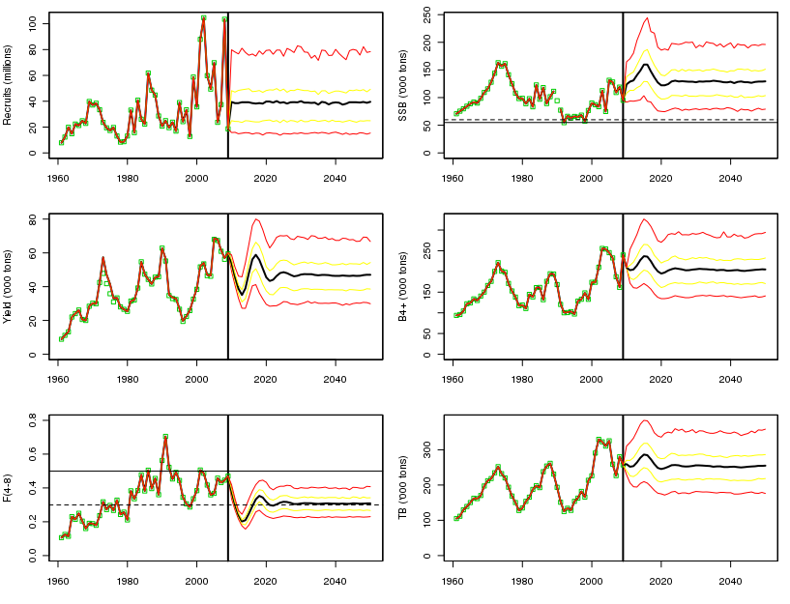
Figure 3.2. Faroe saithe. Recruitment (millions)(top-left), yield (‘000 tones)(middle-left), fishing mortality (Fbar, average over ages 4 to 8)(bottom-left), spawning-stock-biomass (‘000 tones)(top-right), B4+ biomass (‘000 tones, total biomass of non-recruiting ages)(middle-right) and total biomass (‘000 tones)(bottom-right) from stochastic simulations (yellow solid lines represent the 25% and 75% percentiles while solid red lines show the 5% and 95% percentiles)

References
Anon. 2010. An MSY Framework for Advice. Draft (Version 1.5). ICES 2010
Anon. 2010. Benchmark Workshop on Roundfish 2010 report. Faroe saithe. ICES 2010.
Anon. 2010. ICES North-Western Working Group report. ICES 2010
Anon. 2011. ICES North-Western Working Group report. ICES 2011
Anon. 2011. Report of the Workshop on Implementing the ICES Fmsy Framework (WKFRAME-2). ICES 2011
FLR: an open-source framework for the evaluation and development of management strategies.
Reinert, J. 2010. Fundir í ráðgevandi nevndini (ACOM) hjá Altjóða Havrannsóknarstovninum (ICES) í mai/juni 2010. Niðurstøður og tilmæli viðvíkjandi høvuðs botnfiskastovnunum undir Føroyum saman við stuttum yvirliti yvir tilmælum fyri aðrar stovnar av áhuga fyri Føroyar.
Reinert, J. 2011. Stovnsmetingar 2011 og útlit fyri tosk, hýsu og upsa og ICES ráðgeving fyri 2012.

